**Exercise 4: Employee Management System**

**Array in Memory**

* Arrays are stored in **contiguous memory locations**.
* Each element can be accessed directly using its **index**.
* The index starts from 0 and goes up to the size of the array minus 1.

**Advantages of Arrays**

* **Fast access**: Direct access to any element in constant time O(1).
* **Simple structure**: Easy to declare and use.
* **Efficient for fixed-size data**: Works well when the number of items is known.

**Output**

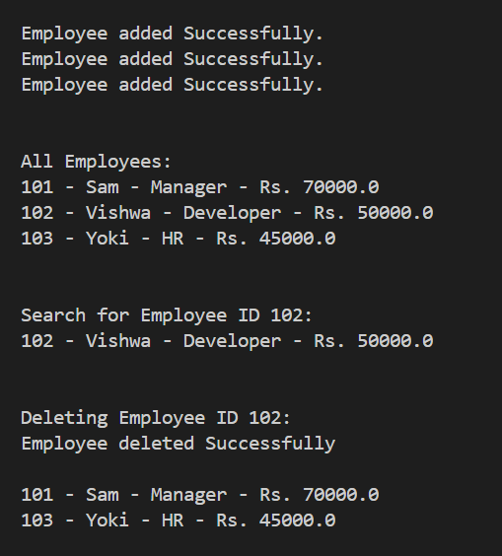

**Time Complexity of Operations**

* **Add**: Fast and takes constant time if space is available – O(1).
* **Search**: Takes time proportional to the number of employees – O(n).
* **Traverse**: Goes through each employee one by one – O(n).
* **Delete**: Slower because items need to be shifted after removal – O(n).

**Limitations of Arrays**

* Size is fixed and cannot grow once declared.
* Deleting an item requires shifting the rest, which takes time.
* Not suitable when adding or removing items frequently.

**When to Use Arrays**

* When the total number of items is small and known in advance.
* When you need quick access to elements by position.
* When a simple and memory-efficient structure is preferred.